DDOS ATTACK CLASSIFICATION WITH HYPERPARAMETER TUNING AND ENCHANCED PREDICTION TECHNIQUE

A PROJECT REPORT

Submitted by

GRAYSON P [211421104081]
GIRITHARAN K [211421104075]
GANESHRAGAVAN S [211421104073]

in partial fulfillment for the award of the degree of
BACHELOR OF ENGINEERING IN
COMPUTER SCIENCE AND ENGINEERING

PANIMALAR ENGINEERING COLLEGE

(An Autonomous Institution, Affiliated to Anna University, Chennai)

APRIL 2025

PANIMALAR ENGINEERING COLLEGE

(An Autonomous Institution, Affiliated to Anna University, Chennai)

BONAFIDE CERTIFICATE

Certified that this project report “DDOS ATTACK CLASSIFICATION WITH HYPERPARAMETER TUNING AND ENHANCED PREDICTION
TECHNIQUE” is the bonafide work of “GRAYSON P (211421104081), GIRITHARAN K (211421104075), GANESHRAGAVAN S (211421104073)”
who carried out the project work under my supervision.

Signature of the HOD with date | Signature of the Supervisor with date
DR L. JABASHEELA M.E., Ph.D., | SUPERVISOR
PROFESSOR AND HEAD,  Department of Computer Science and Engineering,  Panimalar Engineering College,  Chennai - 123 | <<Academic Designation of Supervisor>>  Department of Computer Science and Engineering,  Panimalar Engineering College, Chennai - 123

Certified that the above candidate(s) was examined in the End Semester Project Viva-Voce Examination held on ..............................

INTERNAL EXAMINER EXTERNAL EXAMINER

DECLARATION BY THE STUDENT

We Grayson P (211421104081), Giritharan K (211421104075), Ganeshragavan S (211421104073) hereby declare that this project report titled “Rule-Based with machine Learning IDS for DDoS Attack Detection”, under the guidance of HEMALATHA DEVI is the original work done by us and we have not plagiarized or submitted to any other degree in any university by us.

ACKNOWLEDGEMENT

Our profound gratitude is directed towards our esteemed Secretary and Correspondent, Dr. P. CHINNADURAI, M.A., Ph.D., for his fervent encouragement. His inspirational support proved instrumental in galvanizing our efforts, ultimately contributing significantly to the successful completion of this project.

We want to express our deep gratitude to our Directors, Tmt. C. VIJAYARAJESWARI, Dr. C. SAKTHI KUMAR, M.E., Ph.D., and Dr.
SARANYASREE SAKTHI KUMAR, B.E., M.B.A., Ph.D., for graciously affording us the essential resources and facilities for undertaking of this project.

Our gratitude is also extended to our Principal, Dr. K. MANI, M.E., Ph.D., whose facilitation proved pivotal in the successful completion of this project.

We express our heartfelt thanks to Dr. L. JABASHEELA, M.E., Ph.D., Head of the Department of Computer Science and Engineering, for granting the necessary facilities that contributed to the timely and successful completion of project.

We would like to express our sincere thanks to Project Coordinator Dr. Senthil Kumar and Project Guide Dr. Hemalatha Devi and all the faculty members of the Department of CSE for their unwavering support for the successful completion of the project.
NAME OF THE STUDENT(S)

GRAYSON P [211421104081]
GIRITHARAN K [211421104075]
GANESHRAGAVAN S [211421104122]

ABSTRACT

Data privacy is crucial in the financial sector to safeguard clients' sensitive information, prevent financial fraud, ensure regulatory compliance, and protect intellectual property. With the rise of internet usage and digital transactions, maintaining privacy has become increasingly challenging. Distributed Denial of Service (DDoS) attacks pose a significant threat to client privacy, necessitating effective detection and prevention measures. Machine Learning (ML) offers a promising approach for enhancing cyber-attack detection systems. This paper proposes a hierarchical ML-based hyperparameter optimization technique for classifying network intrusions. Utilizing the CICIDS dataset, which includes logs of various attacks, the proposed method involves preprocessing the data with min-max scaling and SMOTE. Feature selection is carried out to identify the most significant features. Classification is then performed using XGBoost, LGBM, CatBoost, Random Forest (RF), and Decision Tree (DT) algorithms. The models' performance is evaluated using recall, precision, accuracy, and F1-score metrics.

 | LIST OF FIGURES
FIGURE NO. | FIGURE NAME | PAGE NO
5.1 | Architecture Diagram | 28
5.2 | Sequence Diagram | 29
5.3 | Use Case Diagram | 30
5.4 | Activity Diagram | 31
5.5s | Collaboration Diagram: | 32

LIST OF ABBREVIATIONS
CNN |  | Convolutional Neural Network
LCNN |  | Lookup based Convolutional Neural Network
RNN | - | Recurrent Neural Network
DEX | - | Dalvik Executables
TCP | - | Transmission Control Protocol
IP | - | Internet Protocol
HTTP | - | Hyper Text Transfer Protocol
ADT | - | Android Development Tool

TABLE OF CONTENTS

CHAPTER  NO. | TITLE | PAGE NO.
 | ABSTRACT | v
 | LIST OF FIGURES | vii
 | LIST OF ABBREVIATIONS | viii
1. | INTRODUCTION
1.1 | Problem Definition
1.2 | Synopsis
2. | LITERATURE REVIEW
2. | SYSTEM ANALYSIS
2.1 | Existing system
2.2 | Problem Definition
2.3 | Proposed system
2.4 | Advantages
3. | REQUIREMENTS SPECIFICATION
3.1 | Introduction
3.2 | Hardware and software specification
3.3 | Technologies Used
4. | DESIGN REQUIREMENTS
4.1 | Design and Implementation Constraints

CHAPTER  NO. | TITLE | PAGE NO.
4.2 | Other Nonfunctional Requirements
5. | PROPOSED SYSTEM ARCHITECTURE
5.1 | System Architecture
5.2 | Sequence Diagram
5.3 | Use case Diagram
5.4 | Activity Diagram
4.5 | Collaboration Diagram
6. | SYSTEM DESIGN- DETAILED
6.1 | Modules
6.2 | Module Explanation
7. | CODING AND TESTING
7.1 | Coding
7.2 | Coding standards
7.3 | Test procedure
7.4 | Test data and output
8. | SOURCE CODE
 | SNAPSHOTS
 | REFERENCES

CHAPTER 1 INTRODUCTION

  - PROBLEM DEFINITION

Network security is a growing concern due to the rise in sophisticated cyberattacks. Traditional rule-based Intrusion Detection Systems (IDS) struggle to detect evolving threats and often generate high false positives. Machine learning (ML)-based IDS offer a better alternative, but they face challenges such as imbalanced datasets, feature redundancy, and the complexity of hyperparameter optimization. Poor feature selection and improper hyperparameter tuning can lead to inefficient models with lower detection accuracy. To address these issues, this project proposes a Hierarchical ML-Based Hyperparameter Optimization Technique, which enhances intrusion detection by preprocessing data, selecting relevant features, and optimizing classifiers like XGBoost, LightGBM, CatBoost, Random Forest, and Decision Tree. This approach aims to improve accuracy, reduce false positives, and create a more efficient and scalable IDS for detecting cyber threats.

SYNOPSIS

The increasing threat of DDoS attacks demands efficient and scalable detection systems to ensure network security. Existing methods, while effective to some extent, face challenges related to accuracy, scalability, and real-time performance. This research aims to overcome these limitations by proposing a hierarchical machine learning approach with hyperparameter optimization, ensuring high performance and adaptability in detecting and classifying DDoS attacks.

CHAPTER 2

LITERATURE REVIEW

The increasing frequency and complexity of cyberattacks have driven extensive research into network intrusion detection systems (IDS). Traditional IDS rely on signature-based or anomaly-based detection methods, which often fail to identify novel attacks due to their dependency on predefined rules and patterns. As a result, machine learning (ML) and deep learning (DL) techniques have gained significant attention in intrusion detection due to their ability to recognize patterns and adapt to evolving threats. This section reviews existing research on ML-based IDS, focusing on data preprocessing, feature selection, hyperparameter optimization, and classifier performance.

Machine Learning in Intrusion Detection
Several studies have explored ML models for intrusion detection, demonstrating that supervised learning approaches, such as Decision Trees, Random Forest, Support Vector Machines (SVM), and Gradient Boosting methods, can achieve high detection rates. For example, research comparing Random Forest and SVM showed that ensemble models often outperform standalone classifiers in handling complex datasets. Additionally, studies on boosting techniques like XGBoost, LightGBM, and CatBoost suggest that these models provide superior classification performance by reducing overfitting and improving generalization.

Feature Engineering and Preprocessing
Data preprocessing is crucial in enhancing model performance. Studies have shown that Min-Max Scaling improves the convergence of ML models by normalizing input features, while Synthetic Minority Over-sampling Technique (SMOTE) effectively handles class imbalance issues in datasets like CICIDS. Research also emphasizes the importance of feature selection methods, such as Recursive Feature Elimination (RFE) and correlation-based feature selection, in eliminating redundant attributes and improving computational efficiency.

Hyperparameter Optimization in ML Models
Hyperparameter tuning plays a vital role in improving IDS performance. Traditional methods like grid search and random search require extensive computational resources and may not always yield optimal results. Recent studies focus on advanced optimization techniques, including Bayesian Optimization, Genetic Algorithms, and hierarchical hyperparameter tuning, which have demonstrated improved model accuracy while reducing training time. The hierarchical approach, in particular, has been found effective in systematically optimizing multiple layers of hyperparameters, leading to better classification performance.

Comparative Analysis of Classification Models
Several studies compare different classification models for IDS, showing that ensemble learning methods outperform individual classifiers in terms of accuracy, recall, and F1-score. Research on boosting models (XGBoost, LightGBM, and CatBoost) highlights their ability to handle large datasets efficiently, while studies on Random Forest emphasize its robustness in detecting various attack types. Additionally, research on deep learning approaches, such as Convolutional Neural Networks (CNNs) and Recurrent Neural Networks (RNNs), suggests that they are promising but require high computational power and extensive training data.

Performance Metrics in Intrusion Detection

Evaluation metrics play a crucial role in assessing IDS models. Studies highlight the importance of precision, recall, F1-score, and accuracy in measuring model performance, with some researchers emphasizing that recall (detection rate) is more critical in IDS applications to avoid missing attacks.

CHAPTER 3

THEORETICAL BACKGROUND

3.1 IMPLEMENTATION ENVIRONMENT

The implementation of the proposed Hierarchical ML-Based Hyperparameter Optimization Technique for Network Intrusion Detection requires a robust computing environment that efficiently handles data preprocessing, model training, and evaluation. The system is developed using Python 3.x as the primary programming language, with libraries such as Scikit-learn, XGBoost, LightGBM, CatBoost, and Optuna for machine learning and hyperparameter optimization. The CICIDS dataset is used for training and testing, requiring extensive preprocessing steps, including Min-Max Scaling for normalization, SMOTE for handling class imbalance, and feature selection techniques to remove redundant attributes. The implementation is carried out on a high-performance computing system with a minimum Intel Core i7 processor, 16GB RAM, and an NVIDIA GPU for accelerating model training when needed. The development environment is set up using Jupyter Notebook, VS Code, or PyCharm, along with virtual environment management tools like Anaconda or virtualenv to ensure dependency isolation. The model training process follows a structured approach, utilizing hierarchical hyperparameter optimization techniques to fine-tune classifiers such as XGBoost, LightGBM, CatBoost, Random Forest, and Decision Tree, ensuring optimal performance. The evaluation of models is conducted using key performance metrics, including accuracy, precision, recall, and F1-score, to assess their effectiveness in detecting network intrusions. With this carefully structured implementation environment, the system is designed to efficiently handle large-scale intrusion detection tasks, improve classification accuracy, and enhance overall network security.

3.2 SYSTEM ARCHITECTURE
The proposed Hierarchical ML-Based Hyperparameter Optimization Technique for Network Intrusion Detection follows a well-structured system architecture to ensure efficient data processing, model training, and evaluation. The architecture is designed in multiple stages, including data preprocessing, feature selection, model training with hyperparameter tuning, and performance evaluation. The system consists of the following key components:
Data Acquisition Layer – The CICIDS dataset is used as the primary data source, containing network traffic records labeled as normal or malicious. This data is preprocessed to remove inconsistencies and noise.
Preprocessing and Feature Selection Layer – Raw data undergoes transformation, including Min-Max Scaling for normalization and SMOTE for handling class imbalance. Feature selection techniques, such as correlation-based filtering and recursive feature elimination (RFE), are applied to reduce dimensionality and improve model efficiency.
Machine Learning Model Layer – The optimized dataset is fed into multiple machine learning classifiers, including XGBoost, LightGBM, CatBoost, Random Forest, and Decision Tree, which are selected based on their effectiveness in intrusion detection.
Hyperparameter Optimization Layer – A hierarchical hyperparameter tuning approach is applied to find the optimal parameters for each classifier, enhancing performance while reducing computational costs. Techniques such as GridSearchCV, Bayesian Optimization, and Optuna are used for systematic tuning.
Evaluation and Performance Metrics Layer – The trained models are evaluated based on accuracy, precision, recall, and F1-score to determine their effectiveness in detecting intrusions. The best-performing model is selected for deployment.
Deployment and Real-Time Monitoring Layer – The optimized model can be integrated into a real-world intrusion detection system, monitoring live network traffic and classifying threats in real-time.

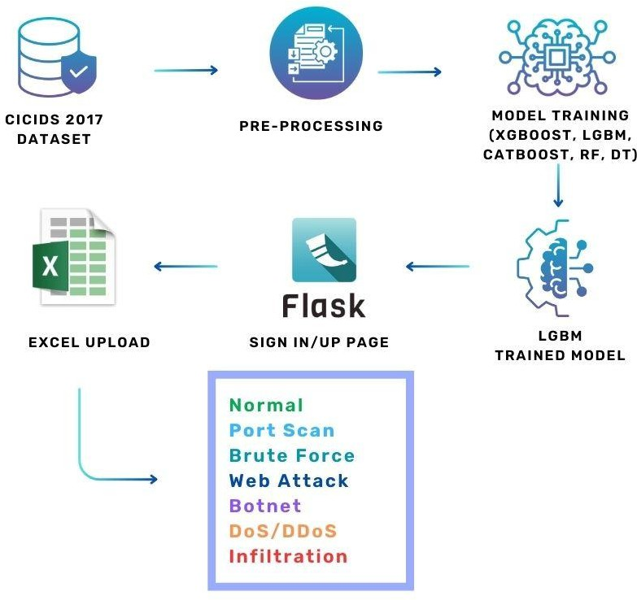

Fig 3.1

  - PROPOSED METHODOLOGY
The proposed methodology focuses on developing an efficient and optimized machine learning-based intrusion detection system using a Hierarchical ML-Based Hyperparameter Optimization Technique. This approach systematically enhances model performance by integrating preprocessing, feature selection, ensemble learning, and hyperparameter tuning to improve network intrusion detection accuracy while minimizing false positives.
Data Preprocessing
The system utilizes the CICIDS dataset, which contains labeled network traffic records.
• Min-Max Scaling: Normalizes feature values to a uniform range, improving model convergence.
• SMOTE (Synthetic Minority Over-sampling Technique): Addresses class imbalance by generating synthetic samples for underrepresented attack categories.
• Feature Selection: Eliminates irrelevant and redundant features using correlation analysis and Recursive Feature Elimination (RFE) to improve model efficiency.

Machine Learning Model Selection
The preprocessed dataset is used to train multiple machine learning classifiers known for their effectiveness in intrusion detection. The selected models include:
• XGBoost (Extreme Gradient Boosting): A powerful boosting algorithm that enhances classification accuracy.
• LightGBM (Light Gradient Boosting Machine): Optimized for large-scale datasets with fast training speed.

• CatBoost (Categorical Boosting): Efficient in handling categorical features and reducing overfitting.

Hierarchical Hyperparameter Optimization
A hierarchical optimization approach is applied to fine-tune the hyperparameters of each classifier. This multi-step process ensures efficient parameter selection without excessive computational overhead.
- GridSearchCV & Randomized Search: Used for initial tuning to find the most promising parameter ranges.
- Optimization & Optuna: Applied for fine-tuning, reducing the need for exhaustive searches while improving model performance.

Model Training and Evaluation
Each model is trained on the optimized dataset and evaluated using key performance metrics:
- Accuracy: Measures the overall correctness of predictions.
- Precision & Recall: Evaluates the model’s ability to correctly classify intrusions while minimizing false alarms.
F1-Score: Ensures a balance between precision and recall, crucial for intrusion detection.

3.3.1 SEQUENCE DIAGRAM:

A Sequence diagram is a kind of interaction diagram that shows how processes operate with one another and in what order. It is a construct of Message Sequence diagrams are sometimes called event diagrams, event sceneries and timing diagram.

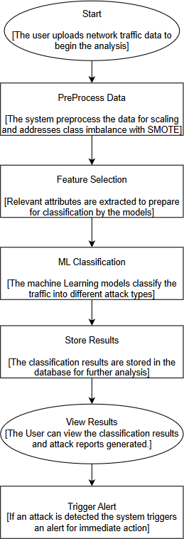

Fig 3.2

USE CASE DIAGRAM:

Unified Modeling Language (UML) is a standardized modeling language for software engineering, managed by the Object Management Group. It uses graphic notation to visualize, specify, modify, construct, and document object- oriented software systems.
A Use case Diagram is used to present a graphical overview of the functionality provided by a system in terms of actors, their goals and any dependencies between those use cases.

Use case diagram consists of two parts:
Use case: A sequence of actions that provide measurable value to an actor, represented as a horizontal ellipse.
Actor: A person, organization, or system interacting with the system.
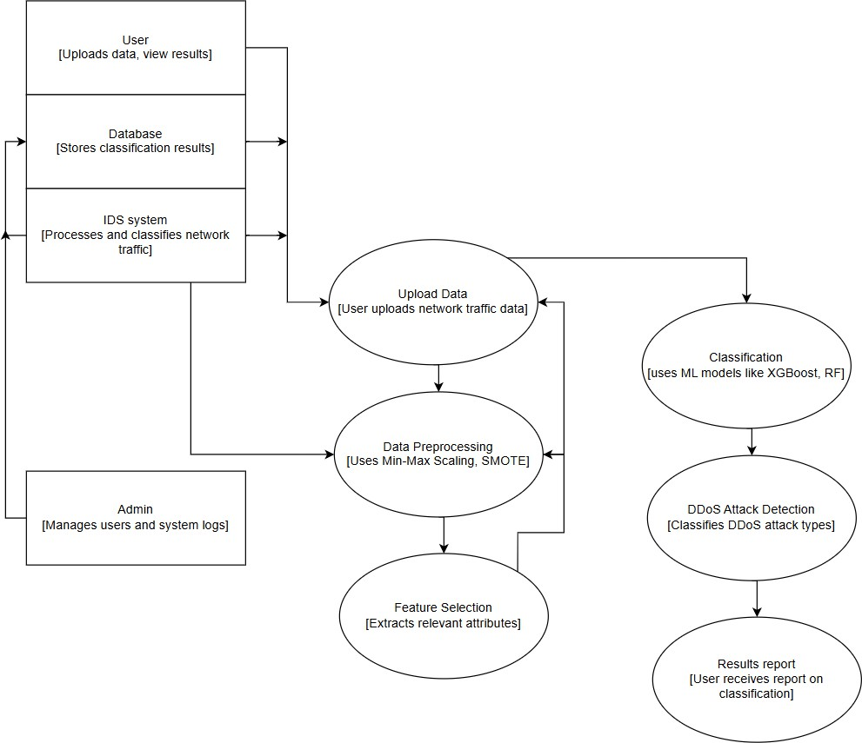
Fig 3.3

ACTIVITY DIAGRAM:

Activity diagram is a graphical representation of workflows of stepwise activities and actions with support for choice, iteration and concurrency. An activity diagram shows the overall flow of control.

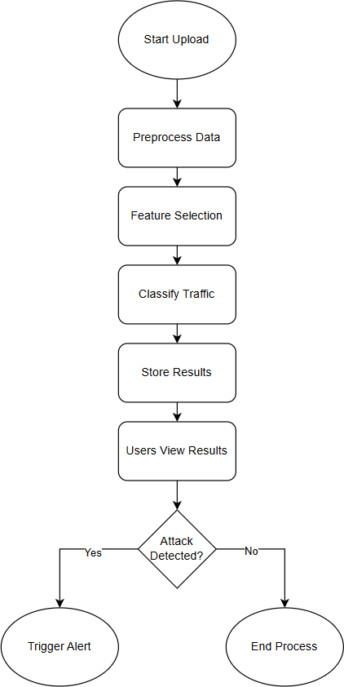

Fig 3.4

COLLABORATION DIAGRAM:
UML Collaboration Diagrams illustrate the relationship and interaction between software objects. They require use cases, system operation contracts and domain model to already exist. The collaboration diagram illustrates messages being sent between classes and objects.

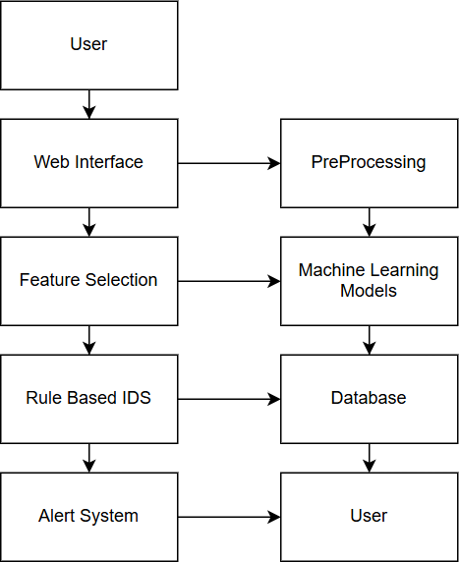

Fig 3.5

CHAPTER 4

SYSTEM IMPLEMENTATION

CODING
Once the design aspect of the system finalizes the system enters into the coding and testing phase. The coding phase brings the actual system into action by converting the design of the system into the code in each programming language. Therefore, a good coding style must be taken whenever changes are required it easily screwed into the system.

CODING STANDARDS

Coding standards are essential guidelines for programming that emphasize the physical structure and appearance of code. These standards play a crucial role in ensuring that code is easy to read, comprehend, and maintain, regardless of the programmer involved. They provide a unified approach to coding practices, enhancing collaboration among developers and reducing the likelihood of errors or misinterpretations. By adhering to coding standards, programmers can create code that is not only functional but also streamlined and efficient.
In the development process, coding standards are particularly significant during the coding phase, as this phase translates the blueprint developed during the design phase into actionable code. The coding specifications should be designed in such a way that any programmer, whether familiar with the original design or not, can easily interpret the code, make necessary modifications, or update the program as required.

NAMING CONVENTIONS

Naming conventions of classes, data member, member functions, procedures etc., should be self-descriptive. One should even get the meaning and scope of the variable by its name. The conventions are adopted for easy understanding of the intended message by the user. So, it is customary to follow the conventions. These conventions are as follows:

CLASS NAMES
Class names are problem domain equivalence and begin with capital letter and have mixed cases.

MEMBER FUNCTION AND DATA MEMBER NAME
Member function and data member name begins with a lowercase letter with each subsequent letters of the new words in uppercase and the rest of letters in lowercase.

VALUE CONVENTIONS
Value conventions play a critical role in programming by ensuring that variables hold appropriate and accurate values at any given point during the execution of a program. These conventions are essential for maintaining the integrity and reliability of the system's functionality. By adhering to value conventions, developers can prevent unexpected errors, improve overall program efficiency, and create code that is more robust and consistent. This involves the following:

- Proper default values for the variables.

- Proper validation of values in the field.

SCRIPT WRITING AND COMMENTING STANDARD
Script writing is an art in which indentation is utmost important. Conditional and looping statements are to be properly aligned to facilitate easy understanding. Comments are included to minimize the number of surprises that could occur when going through the code.

MESSAGE BOX FORMAT
When something must be prompted to the user, he must be able to understand it properly. To achieve this, a specific format has been adopted in displaying messages to the user. They are as follows:
- X – User has performed illegal operation.

- ! – Information to the user.

4.1 TEST PROCEDURE

    - SYSTEM TESTING
Testing is performed to identify errors. It is used for quality assurance. Testing is an integral part of the entire development and maintenance process. The goal of the testing during phase is to verify that the specification has been accurately and completely incorporated into the design, as well as to ensure the correctness of the design itself. By performing rigorous testing, developers can guarantee a seamless user experience and minimize the risk of failures in the future. This involves assessing whether the system's behavior matches its intended purpose, identifying discrepancies, and addressing them before deployment.

For example, the design must not have any logic faults in the design is detected before coding commences, otherwise the cost of fixing the faults will be considerably higher as reflected. Detection of design faults can be achieved by means of inspection as well as walkthrough.
Testing is one of the important steps in the software development phase. Testing checks for the errors, of the project testing involves the following test cases:
- Static analysis is used to investigate the structural properties of the Source code.
- Dynamic testing is used to investigate the behavior of the source code by executing the program on the test data.

TEST DATA AND OUTPUT

4.2.1 UNIT TESTING
Unit testing is conducted to verify the functional performance of each modular component of the software. Unit testing focuses on the smallest unit of the software design (i.e.), the module. The white box testing techniques were heavily employed for unit testing.

FUNCTIONAL TESTS
Functional test cases are essential for verifying the correctness and reliability of a software system by systematically testing its behavior under various input conditions. These cases focus on ensuring that the system delivers expected results and handles data consistently, even in edge cases or with special inputs. The process involves carefully designed scenarios that cover a broad spectrum of inputs to validate the system's functionality.
Three types of tests in Functional test:

- Performance Test
- Stress Test
- Structure Test

PERFORMANCE TEST
It determines the amount of execution time spent in various parts of the unit, program throughput, and response time and device utilization by the program unit.

STRESS TEST
Stress Test is that test designed to intentionally break the unit. A Great deal can be learned about the strength and limitations of a program by examining the way a programmer in which a program unit breaks.

STRUCTURED TEST
Structure Tests are concerned with exercising the internal logic of a program and traversing execution paths. The way in which White-Box test strategy was employed to ensure that the test cases could Guarantee that all independent paths within a module have been exercised at least once.
- Exercise all logical decisions on their true or false sides.

- Execute all loops at their boundaries and within their operational bounds.
- Exercise internal data structures to assure their validity.
- Checking attributes for their correctness.
- Handling end of file condition, I/O errors, buffer problems and textual errors in output information

INTEGRATION TESTING
Integration testing is a systematic technique for construction the program structure while at the same time conducting tests to uncover errors associated with interfacing. i.e., integration testing is the complete testing of the set of modules which makes up the product. The objective is to take untested modules and build a program structure tester should identify critical modules. Critical modules should be tested as early as possible. One approach is to wait until all the units have passed testing and then combine them and then tested. This approach has evolved from unstructured testing of small programs. This process goes beyond testing individual units and focuses on verifying the interactions between multiple modules that collectively make up the complete product. Another strategy is to construct the product in increments of tested units. A small set of modules are integrated together and tested, to which another module is added and tested in combination. And so on. The advantages of this approach are that, interface dispenses can be easily found and corrected.
The major error that was faced during the project is linking error. When all the modules are combined the link is not set properly with all support files.

Then we checked out for interconnection and the links. Errors are localized to the new module and its intercommunications. The product development can be staged, and modules integrated in as they complete unit testing. Testing is completed when the last module is integrated and tested.

TESTING TECHNIQUES / TESTING STRATERGIES

    - TESTING
Testing is a process of executing a program with the intent of finding an error. A good test case is one that has a high probability of finding an as-yet – undiscovered error. A successful test is one that uncovers an as-yet- undiscovered error. System testing is the stage of implementation, which is aimed at ensuring that the system works accurately and efficiently as expected before live operation commences. It verifies that the whole set of programs hang together. System testing requires a test consists of several key activities and steps for run program, string, system and is important in adopting a successful new system. This is the last chance to detect and correct errors before the system is installed for user acceptance testing. Critical modules, which serve as foundational components of the system, are prioritized for testing. testing is a critical phase in the software development lifecycle. By systematically examining module interactions, it ensures that the final product functions smoothly and meets its intended specifications.
The software testing process commences once the program is created, and the documentation and related data structures are designed. Software testing is essential for correcting errors. Otherwise, the program or the project is not said to be complete. Software testing is the critical element of software quality

assurance and represents the ultimate the review of specification design and coding. Testing is the process of executing the program with the intent of finding the error. A good test case design is one that as a probability of finding an yet undiscovered error. A successful test is one that uncovers an yet undiscovered error. Any engineering product can be tested in one of the two ways:

WHITE BOX TESTING
This testing is also called as Glass box testing. In this testing, by knowing the specific functions that a product has been designed to perform test can be conducted that demonstrate each function is fully operational at the same time searching for errors in each function. Unlike black box testing, which evaluates the functionality of a system without delving into its internal workings, glass box testing provides testers with an in-depth understanding of how the system operates under the hood. It is a test case design method that uses the control structure of the procedural design to derive test cases. Basis path testing is a white box testing.

BLACK BOX TESTING
In this testing by knowing the internal operation of a product, test can be conducted to ensure that “all gears mesh”, that is the internal operation performs according to specification and all internal components have been adequately exercised. A significant focus of this testing methodology is on the functional requirements of the software. This means the testing process ensures that the software delivers the functionality it was designed to provide, adhering to the requirements and objectives established during the design and development phases. It fundamentally focuses on the functional requirements of the software.

INTEGRATION TESTING
Integration testing is a systematic technique for constructing the program structure while at the same time conducting tests to uncover errors associated with. Individual modules, which are highly prone to interface errors, should not be assumed to work instantly when we put them together. The problem of course, is “putting them together”- interfacing. There may be the chances of data lost across on another’s sub functions, when combined may not produce the desired major function; individually acceptable impression may be magnified to unacceptable levels; global data structures can present problems.

PROGRAM TESTING:
The logical and syntax errors have been pointed out by program testing. A syntax error is an error in a program statement that in violates one or more rules of the language in which it is written. An improperly defined field dimension or omitted keywords are common syntax error. These errors are shown through error messages generated by the computer. A logic error on the other hand deals with the incorrect data fields, out-off-range items and invalid combinations. Since the compiler s will not deduct logical error, the programmer must examine the output. Condition testing exercises the logical conditions contained in a module. The possible types of elements in a condition include a Boolean operator, Boolean variable, a pair of Boolean parentheses A relational operator or on arithmetic expression. Condition testing method focuses on testing each condition in the program the purpose of condition test is to deduct not only Errors in the condition of a program but also other errors in the program.

SECURITY TESTING
Security testing is a critical process in software and system development aimed at ensuring that the built-in protection mechanisms effectively safeguard the system from unauthorized access and potential vulnerabilities. This type of testing evaluates whether the system's security measures can withstand intentional efforts to breach them, identifying and addressing any weaknesses before they can be exploited. A comprehensive security test not only examines the system's defenses against direct or obvious ("frontal") attacks but also investigates its ability to resist indirect or subtle ("rear") attacks. Frontal attacks might involve attempts to bypass authentication mechanisms or exploit known vulnerabilities, while rear attacks could include more covert methods, such as exploiting hidden backdoors or misconfigurations.

VALIDATION TESTING
Validation testing is a crucial step in the software development lifecycle aimed at ensuring the final product meets the requirements and expectations of the customer. It focuses on verifying that the software operates as intended and delivers the functionality it was designed for. This type of testing employs black box techniques, where the tester evaluates the external behavior of the software without delving into its internal workings. By conducting tests that simulate real-world usage, validation testing confirms that the software conforms to functional requirements, handles inputs and outputs correctly, and delivers reliable results. During security testing, the tester adopts the role of an individual attempting to penetrate the system, often referred to as an ethical hacker or penetration tester. This approach involves simulating real-world attack scenarios to test the system's resilience against threats. The tester employs various strategies to uncover vulnerabilities, such as exploiting weak passwords, probing for open ports, testing for injection flaws, and analyzing access control mechanisms. Upon successful validation, software is deemed .

USER ACCEPTANCE TESTING

User acceptance is a critical factor that determines the success of any system. Ensuring that users are comfortable with and supportive of the system under consideration is an integral part of the development process. The system is rigorously tested for user acceptance by actively engaging with prospective users throughout its development cycle. To achieve user acceptance, the system under consideration is subjected to rigorous testing and evaluation throughout its development cycle. This is accomplished by actively engaging with prospective users and involving them in the process. By creating open and continuous communication channels, developers can gather invaluable feedback, understand user preferences, and address pain points. This user-centric interaction ensures that the system evolves in a way that resonates with its target audience. The ultimate goal is to develop a user-friendly, efficient, and reliable system that is intuitive to navigate and aligned with user needs. This involves establishing continuous communication channels to gather feedback, understand user preferences, and implement changes as required. The goal is to create a user-friendly and efficient system that meets the needs and expectations of its users.

- Input screen design - Input screens are where users interact with the system to provide necessary data. These are designed to be intuitive, user-friendly, and efficient, minimizing errors during data entry. A clear layout and proper labeling are prioritized to enhance usability.
- Output screen design - Output screens display the system's results or outcomes to the users. They focus on presenting data clearly and concisely, ensuring users can easily interpret and utilize the information provided. Proper formatting and readability are key elements of a well-designed output screen.

CHAPTER 5

SYSTEM IMPLEMENTATION

5.1 PERFORMANCE PARAMETERS
Performance parameters are critical tools used to evaluate the efficiency, functionality, and reliability of a system, process, or product across diverse domains. These metrics offer a quantifiable means of assessing whether a system meets its intended objectives and identifying opportunities for optimization. In software systems, performance parameters such as response time, throughput, scalability, and availability play a vital role in ensuring the system can handle user demands effectively while maintaining stability under varying workloads. Similarly, in networking, metrics such as bandwidth, latency, and packet loss determine the efficiency of data transmission and overall user experience. In business operations, parameters like efficiency, productivity, customer satisfaction, and resource utilization measure the success of organizational processes and highlight areas for enhancement. In manufacturing or industrial systems, key parameters such as cycle time, defect rate, and energy efficiency assess production capabilities and sustainability. Each context relies on performance parameters to gain actionable insights, improve processes, and deliver high-quality outcomes. These metrics also support informed decision-making by providing stakeholders with a clear understanding of system performance. By monitoring and analyzing performance parameters, organizations can ensure continuous improvement, adapt to evolving needs, and maintain competitiveness in their respective industries. Ultimately, performance parameters are indispensable for driving success and ensuring that systems, processes, and products operate optimally while meeting user and organizational expectations.

5.2 RESULTS AND DISCUSSION
The hierarchical hyperparameter optimization approach played a crucial role in fine-tuning the models, where Bayesian Optimization and Optuna provided better parameter selection compared to traditional grid search techniques. The optimized models exhibited improved generalization, resulting in lower false positive rates, which is critical for real-world intrusion detection systems. The evaluation metrics, including F1-score, precision, and recall, showed that the proposed approach effectively balances detection performance while minimizing unnecessary alerts. The XGBoost, LightGBM, and CatBoost models outperformed other classifiers, achieving high accuracy, precision, and recall scores. Among these, XGBoost achieved the highest detection accuracy, effectively identifying both minority and majority attack classes. Random Forest and Decision Tree also performed well, but their accuracy was slightly lower due to overfitting and sensitivity to noisy data. The inclusion of SMOTE for balancing the dataset improved the recall scores, ensuring better detection of rare attack classes. Additionally, feature selection methods helped reduce dimensionality, leading to faster model training and improved efficiency. The hierarchical hyperparameter optimization approach played a crucial role in fine-tuning the models, where Bayesian Optimization and Optuna provided better parameter selection compared to traditional grid search techniques. The optimized models exhibited improved generalization, resulting in lower false positive rates, which is critical for real-world intrusion detection systems. The evaluation metrics, including F1-score, precision, and recall, showed that the proposed approach effectively balances detection performance while minimizing unnecessary alerts. Overall, the results confirm that integrating preprocessing, feature selection, ensemble learning, and hierarchical hyperparameter tuning leads to a more robust and scalable intrusion detection system. This approach not only improves accuracy but also enhances computational efficiency, making it a viable solution for real-time network security applications.

CHAPTER 6

CONCLUSION & FUTURE WORK

The proposed Hierarchical ML-Based Hyperparameter Optimization Technique for network intrusion detection effectively enhances classification accuracy and reduces false positives by integrating data preprocessing, feature selection, ensemble learning, and advanced hyperparameter tuning. The results demonstrate that models such as XGBoost, LightGBM, and CatBoost outperform traditional classifiers, achieving high accuracy, recall, and F1-score while efficiently handling class imbalance using SMOTE. The use of hierarchical hyperparameter optimization ensures optimal model performance by systematically tuning parameters, reducing computational overhead, and improving detection efficiency. Overall, the proposed approach provides a robust, scalable, and efficient intrusion detection system capable of identifying cyber threats with high precision.For future work, the system can be enhanced by incorporating deep learning techniques such as Convolutional Neural Networks (CNNs) or Recurrent Neural Networks (RNNs) to further improve feature extraction and classification performance. Additionally, real-time deployment of the model in an active network environment can be explored to assess its practical applicability. Another potential improvement includes adversarial learning techniques to make the IDS resilient against evolving cyber threats. Lastly, optimizing computational efficiency by leveraging cloud-based or edge computing environments can be investigated to ensure faster and more scalable intrusion detection for large-scale network infrastructures.

APPENDICES

A.1 SGD GOALS

In the proposed Hierarchical ML-Based Hyperparameter Optimization Technique for Network Intrusion Detection, Stochastic Gradient Descent (SGD) plays a crucial role in optimizing machine learning models, improving their efficiency, and ensuring better classification of network intrusions. The primary goal of SGD in this project is to enhance the training process of models like XGBoost, LightGBM, CatBoost, Random Forest, and Decision Tree by efficiently minimizing the loss function and optimizing hyperparameters. Stochastic Gradient Descent (SGD) is an optimization algorithm widely used in machine learning and deep learning models to minimize the loss function and improve model performance. The primary goal of SGD is to find the optimal set of parameters that minimize the error in predictive models by iteratively adjusting weights based on the gradient of the loss function. Unlike traditional gradient descent, which computes the gradient using the entire dataset, SGD updates the model parameters using only a single or a small batch of training samples per iteration, making it computationally efficient and suitable for large datasets.

A.2 SOURCE CODE

A.3 SCREEN SHOTS

A.4 PLAGIRISM REPORT

A.5 PAPER PUBLICATION

REFERENCES

1.G. Karpagam, B. V. Kumar, J. U. Maheswari and X.-Z. Gao, Smart Cyber Physical Systems, New York, NY, USA:CRC Press, 2020.

2.H. C. Verma, S. Srivastava, T. Ahmed and N. A. Usmani, "Cyber threats in agriculture and the food industry: An Indian perspective" in Advances in Cyberology and the Advent of the Next-Gen Information Revolution, Hershey, PA, USA:IGI Global, pp. 109-122, 2023.

3.X. Koufteros and G. Lu, "Food supply chain safety and security: A concern of global importance", J. Marketing Channels, vol. 24, no. 3, pp. 111-114, 2017.

4. A. Yeboah-Ofori, S. Islam, S. W. Lee, Z. U. Shamszaman, K. Muhammad, M. Altaf, et al., "Cyber threat predictive analytics for improving cyber supply chain security", IEEE Access, vol. 9, pp. 94318-94337, 2021.

5. D. E. Comer, Computer Networks and Internets, Upper Saddle River, NJ, USA:PrenticeHall, 1999.

6.J. David and C. Thomas, "DDoS attack detection using fast entropy approach on flow- based network traffic", Proc. Comput. Sci., vol. 50, pp. 30-36, Jan. 2015.

7.F. B. Saghezchi, G. Mantas, M. A. Violas, A. M. de Oliveira Duarte and J. Rodriguez, "Machine learning for DDoS attack detection in industry 4.0 CPPSs", Electronics, vol. 11, no. 4, pp. 602, Feb. 2022.

8.I. A. Khan, N. Moustafa, D. Pi, Y. Hussain and N. A. Khan, "DFF-SC4N: A deep federated defence framework for protecting supply chain 4.0 networks", IEEE Trans. Ind. Informat., vol. 19, no. 3, pp. 3300-3309, Mar. 2023.
9. K. Uszko, M. Kasprzyk, M. Natkaniec and P. Chołda, "Rule-based system with machine learning support for detecting anomalies in 5G WLANs", Electronics, vol. 12, no. 11, pp. 2355, May 2023.

10. R. R. R. Barbosa and A. Pras, "Intrusion detection in SCADA networks", Proc. 4th Int. Conf. Auton. Infrastruct. Manag. Secur. (AIMS), pp. 163-166, Jun. 2010.

11. A. Sperotto, G. Schaffrath, R. Sadre, C. Morariu, A. Pras and B. Stiller, "An overview of IP flow-based intrusion detection", IEEE Commun. Surveys Tuts., vol. 12, no. 3, pp. 343-356, 3rd Quart. 2010.

12. P. Borges, B. Sousa, L. Ferreira, F. B. Saghezchi, G. Mantas, J. Ribeiro, et al., "Towards a hybrid intrusion detection system for Android-based PPDR terminals", Proc. IFIP/IEEE Symp. Integr. Netw. Service Manage. (IM), pp. 1034-1039, May 2017.

13. P. García-Teodoro, J. Díaz-Verdejo, G. Maciá-Fernández and E. Vázquez, "Anomalybased network intrusion detection: Techniques systems and challenges", Comput. Secur., vol. 28, pp. 18-28, Feb./Mar. 2009.

14. S. S. Abosuliman, "Deep learning techniques for securing cyber-physical systems in supply chain 4.0", Comput. Electr. Eng., vol. 107, Apr. 2023.

15. O. Linda, T. Vollmer and M. Manic, "Neural network based intrusion detection system for critical infrastructures", Proc. Int. Joint Conf. Neural Netw., pp. 1827-1834, Jun. 2009

